1. customers who are either from newyork or have grade<100

select customer_id,cust_name,city,grade,salesman_id

from customer

where city='new york' or grade<100;

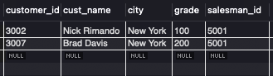

2. customers in new york who gave grade value above 100.

select customer_id,cust_name,city,grade,salesman_id

from customer

where city='new york' and grade>100;

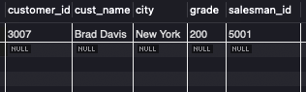

3.orders that exceed 50% of the target value of 6000.

select ord_no, round((purch_amt/6000)*100,2)as achieved,round ((100- purch_amt/6000)*100,2) as unachieved

from orders

where purch_amt > 6000*0.5;

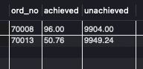

4. calculate the total purchase amount of all orders

select ord_no,sum(purch_amt) as 'total_amt'

from orders

Group by ord_no;

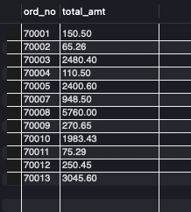

5.the highest purchased amount ordered by each customers

select customer_id, max(purch_amt) as max_purchase

from orders

group by customer_id;

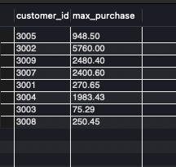

6. calculate the average product price

select avg(pro_price) as 'avg_price'

from item_mast;

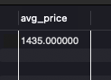

7. employees whose department is located at toronto.

select e.first_name,e.last_name,e.employee_id,e.job_id

from employees e

join departments d

on e.department_id= d.department_id

join locations l

on d.location_id=l.location_id

where l.city='toronto';

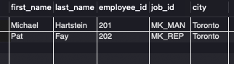

8. employees whose salary is lower than that of employees whose job title is MK_MAN.excluding mk_man

select employee_id,first_name,last_name,job_id

from employees

where salary<

(select salary

from employees

where job_id='MK_MAN')

and job_id!= 'MK_MAN';

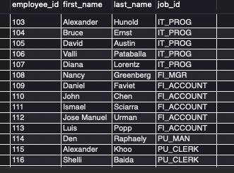

9. employees whose department id is 40 or 80.

select e.first_name, e.last_name, d.department_id,d.department_name

from employees e

join departments d

on e.department_id=d.department_id

where d.department_id in (40,80);

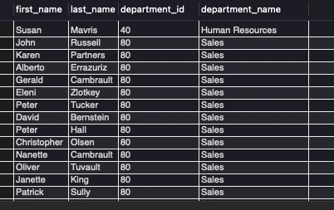

10.calculation of avg. salary, number of employees who are getting commission

select d.department_name, avg(e. salary) as avg_salary,count(commission_pct) as emp_com

from employees e

join departments d

on e.department_id = d.department_id

group by d.department_id;

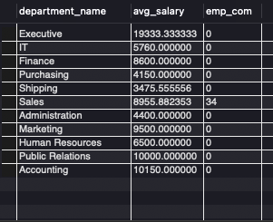

11. employees with the same designation to 169.

select first_name,last_name,job_id,department_id

from employees

where job_id=

(select job_id

from employees

where employee_id= 169)

and employee_id!=169;

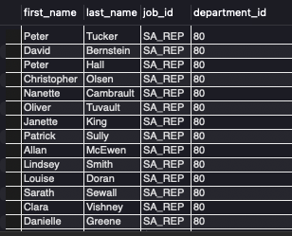

12. employees who earns more than avg. salary

select employee_id,first_name,last_name

from employees

where salary >

(select avg(salary)

from employees);

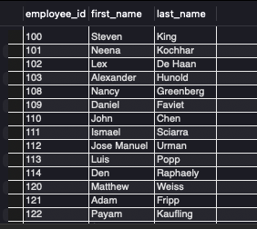

13. employees who work in finance department

select d.department_id, e.first_name,e.job_id,d.department_name

from employees e

join departments d

on e.department_id= d.department_id

where d.department_name= 'finance';

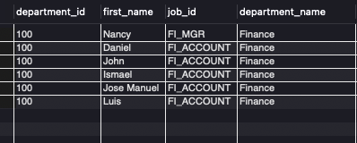

14. employees who earn less than id 182.

select employee_id, first_name,last_name,salary

from employees

where salary<

(select salary

from employees

where employee_id=182)

and employee_id!=182;

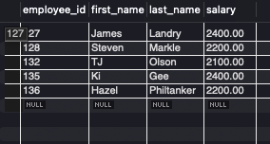

15. procedure for counting employees in each department.

delimiter //

create procedure

countemployeesbydept()

begin

select department_id,

count(*) as emp_count

from employees

group by department_id;

end //

delimiter ;

Call countemployeesbydept;

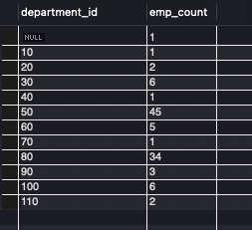

16. procedure for adding new employees

delimiter //

create procedure

addnewemployee (

in p_employee_id int unsigned,

in p_first_name varchar(20),

in p_last_name varchar(25),

in p_email varchar(25),

in p_phone_number varchar(20),

in p_hire_date date,

in p_job_id varchar(10),

in p_salary decimal (8,2),

in p_commission_pct decimal(2,2),

in p_manager_id int unsigned,

in p_department_id int unsigned)

begin

insert into employees

(employee_id,first_name,last_name,email,phone_number,hire_date,job_id,salary,commission_pct,manager_id,department_id)

values(p_employee_id, p_first_name,p_last_name,p_email,p_phone_number,p_hire_date,p_job_id,p_salary,p_commission_pct,p_manager_id,p_department_id);

end //

delimiter ;

17. deleting employees from specific department

delimiter //

create procedure

deleteemployeesbydept(

in p_department_id int)

begin

delete from employees

where department_id=p_department_id;

end //

delimiter ;

18.procedure for top paid employees in each department

delimiter //

create procedure

gettoppaidemployee ()

begin

select salary, employee_id,department_id, max(salary) as max_sal

from employees

group by department_id;

end //

delimiter ;

call gettoppaidemployee() ;

19. changing employee salary and job role

delimiter //

create procedure

promoteEmployee (

in p_new_salary decimal(8,2),

in p_employee_id int,

in p_new_job_id varchar(20)

)

begin

update employees

set salary=p_new_salary,

job_id=p_new_job_id

where employee_id=p_employee_id ;

end //

delimiter ;

20. new manager to all employees in a specific department

delimiter //

create procedure

assignmanagertodepartment (

in p_department_id int,

in p_manager_id int)

begin

update employees

set manager_id=p_manager_id

where department_id=p_department_id ;

end //

delimiter ;

theorycal assignment

-- 1. compare sql and nosql databases

1. full form

sql. : structured query language

nosql : not only sql

2. data type

sql. : it uses relational databases.

nosql : it uses distributed databases.

3. data form

sql. : data used for sql is mostly in the form of table, rows and columns.

nosql : data used for nosql is in the form of graphs, documents etc.

4. examples

sql : mysql, postgresql,oracle etc.

nosql : mongoDB, couchDB etc.

– 2. normlization vs denormalization

1.NORMALIZATION

i) what is normlization?

Normalization is the process for organizing data to eliminate redundancy.

ii)objectives:

Remove the duplicate data

Eliminate redundancy

iii)normal forms:

1NF

2NF

3NF

BCNF

2.DENORMALIZATION

i) what is denormalization?

Denormalization is the process of combining normalized data.

ii)objectives:

Optimize read operation

Improve query performance